Most Popular

Bald Mountain—2nd Most-climbed
Adirondack mountain, best views over
the Fulton Chain of Lakes.
TOBIE Trail Pedestrian Recreational Pathway
Connecting communities of the Central Adirondacks Trail #1
Clear Pond
Big Moose Station Stillwater & Beaver River

21

Big Moose Rd

West Pond

Big Moose Lake

Shallow Lake
Big Moose

Maple Ridge— Accessible off Park Ave Hilly, Fit Trail exercise stations,
connects to McCauley Trail System.
McCauley Mt.—Trails at top, ski trails

Indepedence Lake

Little Safford Pond
X
Carter RR Station

Trail
#8
Carter Road

1

Safford Pond

Safford Pond Trail

Moss
Lake

Windfall Pond
14

Queer Lake
13

also, great views of Fulton Chain. Trails at bottom connect to Maple Ridge System.
Moss Lake— Nice woodland trail with
Trail #9

Trail #1

1 TOBIE Trail
TOBIE Trail

Steel Bridge

West

N. Rondaxe Road
Rondaxe Lake
15

Sis Lake

22

Big Moose Rd

Cascade Lake

Cascade Falls

Ferd’s Bog
4

Brown’s Tract Ponds

constant views of lake and wildlife.
Most Scenic
Bald Mt; McCauley Mt (views to High Peaks Region); Vista Trail; Rocky Mt

Trail #7

North Branch Moose River

Trail #3
1
TOBIE Trail
Town of Webb Trail System
Wheeler Pond
Lake

S. Rondaxe Road

Rondaxe Road

1
TOBIE Trail
Mt. Pond

18 1

Vista Trail18
TOBIE Trail
1 Trail #5
Bubb Lake

3 Eagle Bay
1

Rocky Mt.
8

1b
TOBIE Trail

Uncas Road

17

Black Bear Mountain

Sixth Lake

Seventh Lake NYS Rt 28
Eighth Lake

Cathedral Pines
5

Middle Settlement Lake
20

Trail #6

Elise

Public
Fire Tower

Fly Pond

Cary Lake
Fourth Lake

Inlet
5th Lake

Fern Park
Limekiln Lake
Campground

Limekiln Lake

7 23
Moose River Mt
Lookout

North Street Rec Park

Old Forge

Bald Mt Pond
6

Bald Mountain
11 12
Alger Island

Helldiver Pond
Moose River Plains

Okara Lakes NYS Rt 28

Old Forge
Visitor Center
TOBIE Trail
1

Enchanted Forest Water Safari
Camping Resort

Hollywood Hills

Third Lake

Alger Is. access

Short-Flat:
Quiver Pond

South Shore Road

To Utica
Thendara
Train Sta
NYS Rt 28
Moose River
First Lake

Second

1 TOBIE Trail: Pedestrian Recreation (hike and bike) Trail connecting area communities

Moose River
Adirondack
Scenic RR

1a TOBIE Trail

Upper
Joy Tract Road

9
Maple Ridge
Fit Trail

South Shore Road
Lake

South Shore Road
(TOBIE: Thendara-Old Forge-Big Moose-Inlet-Eagle Bay)

1a Thendara—Old Forge: 2mi. (paved) Train Station in Thendara to North Street.
1b EBay—Inlet: 2mi. (paved) Eagle Bay Welcome Center to Inlet Arrowhead Park.

Old Lock n Dam
2
Bisby Road 16

Lock & Dam— 1 mi. from Green Bridge in Thendara to Moose River site.
- Bubb Lake .5 mi. /Sis Lake .7 mi.— Forest trail to small, scenic lakes.

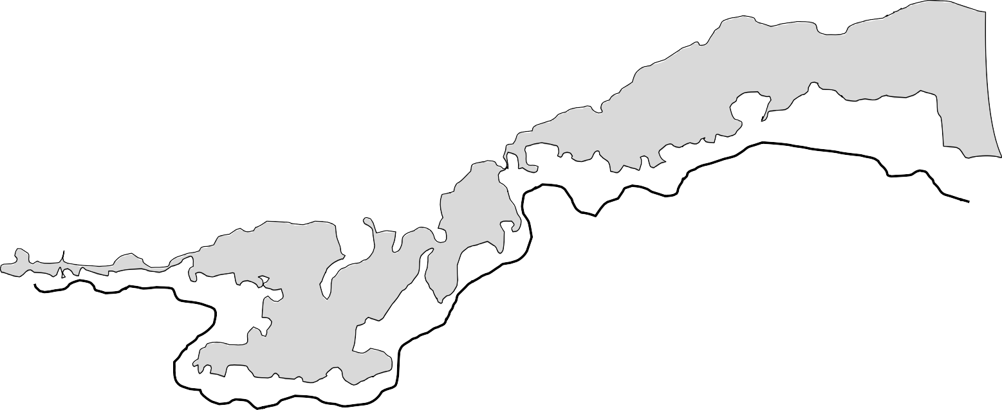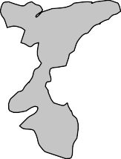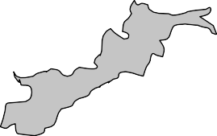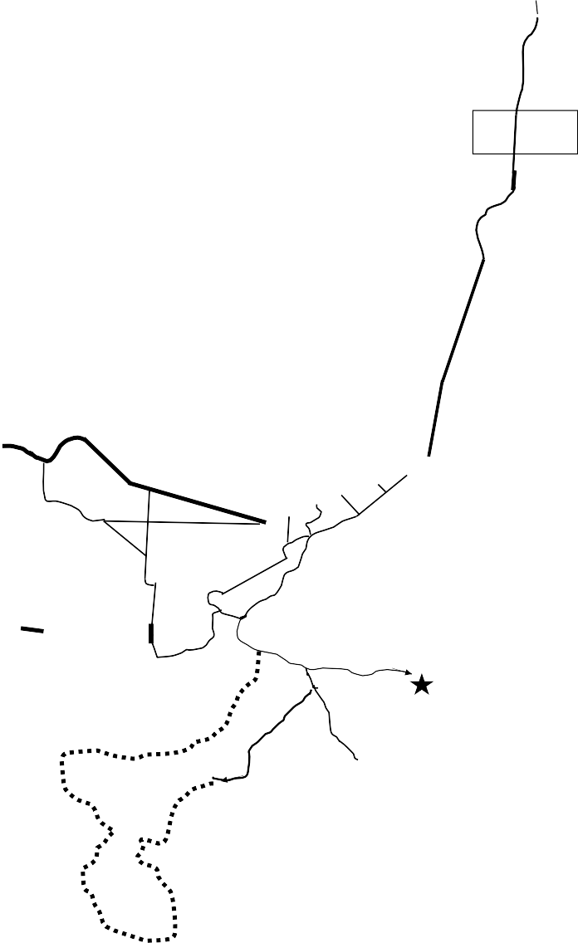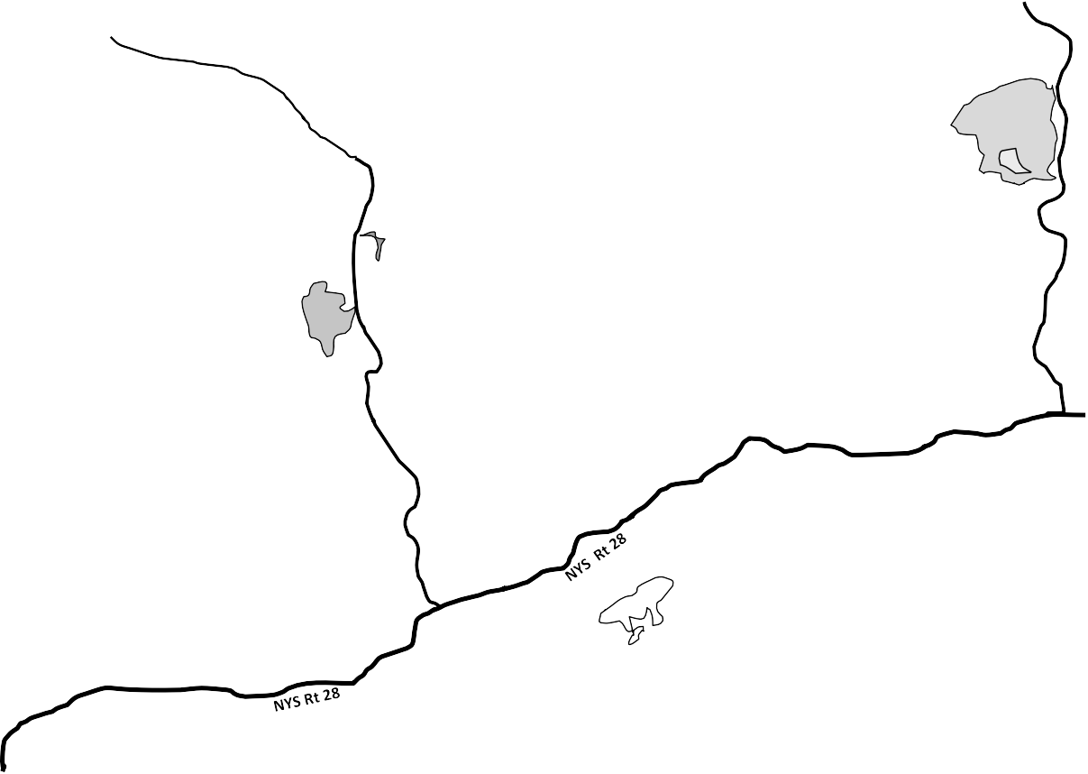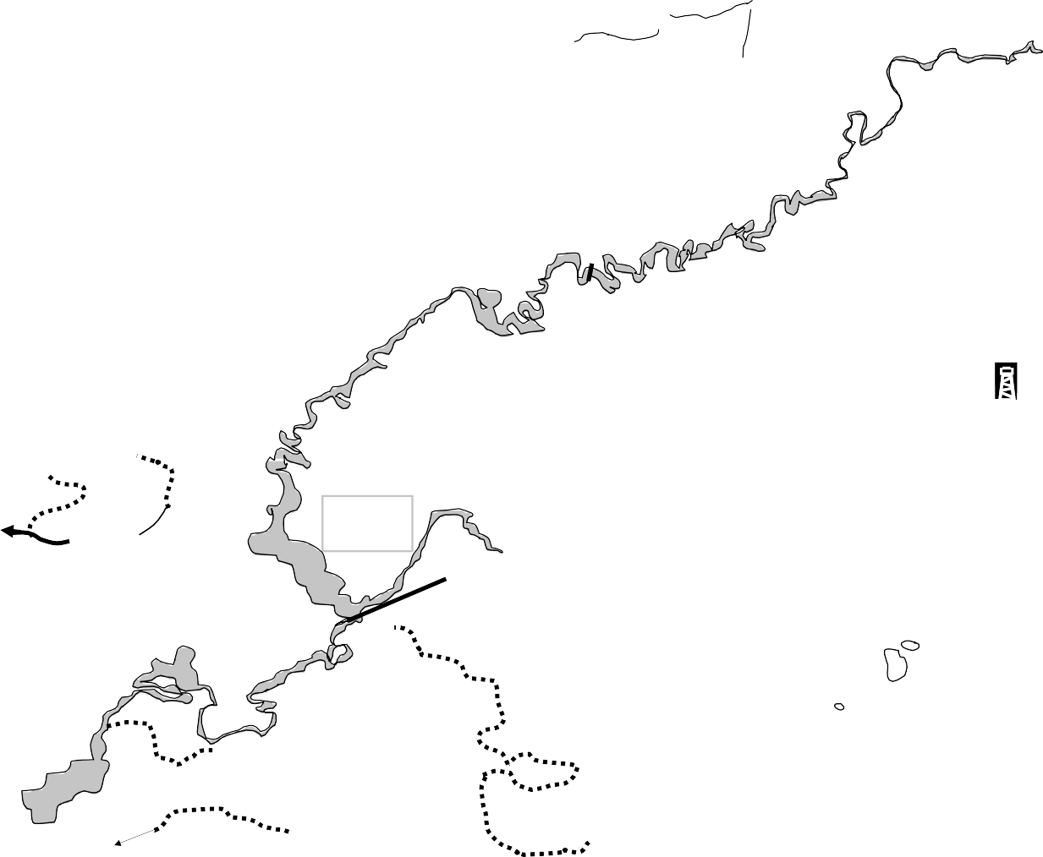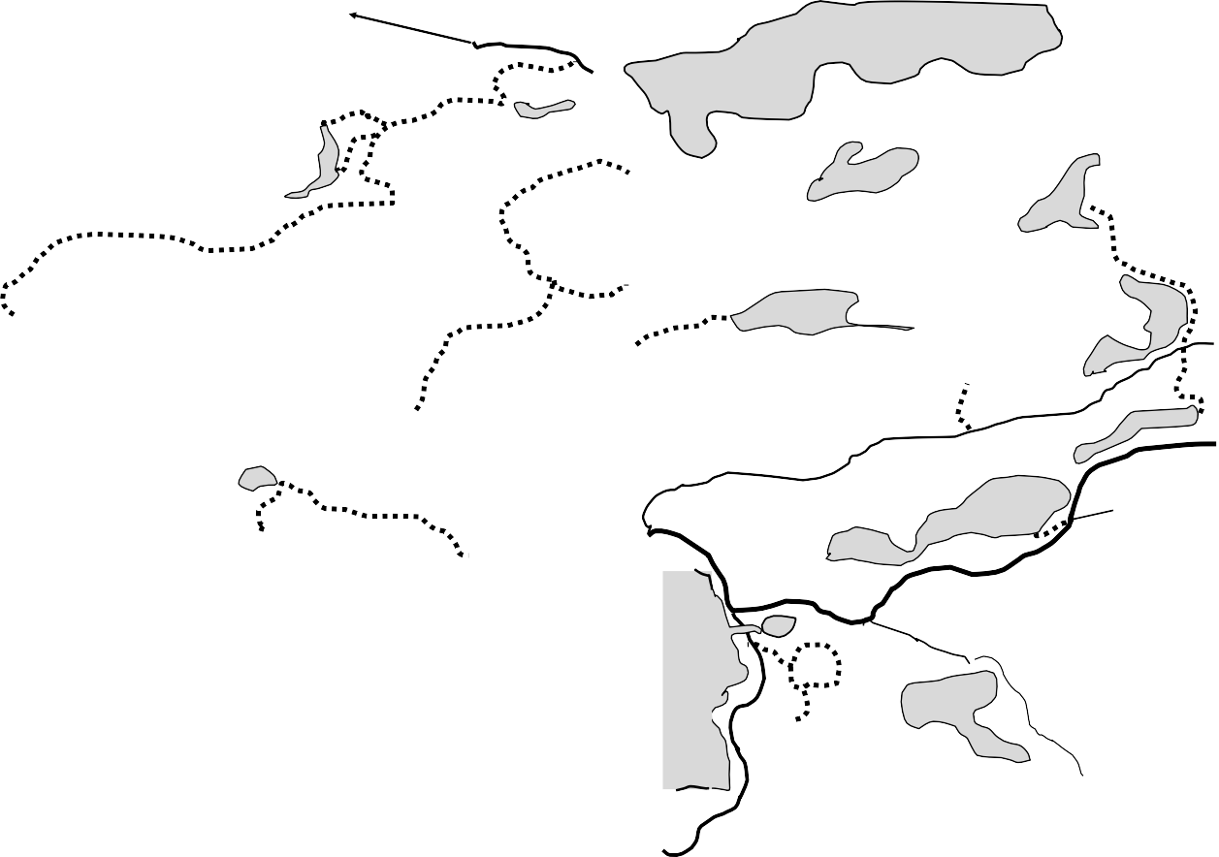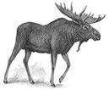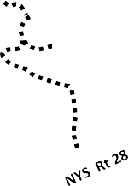To Nelson Lake
Green Bridge

10

Nicks Lake

Nicks Lake

To Bisby
State Campground

McCauley Mountain

Summer Scenic Chairlift Ride
South Shore Road

Old Forge Area
HIKING
Town of Webb

Ferd’s Bog— 500yds, half on boardwalk to marsh; wildlife and carnivorous plants.
- Cathedral Pines— 200yds. to old-growth White Pines on shores of Seventh Lake.
Short/Climb: 6 Bald Mt/7 Moose River Mt/8 Rocky Mt/9 Maple Ridge
Moderate/Flat: 10 Nicks Lake/11 Fly Pond-Cary Lake/12 Fern Park Loops/13 Shallow Lake/14 Moss Lake/15 Bubb Lake-Sis Lake-Moss Lake

Moderate/Climb: 16 Maple Ridge-McCauley/17 Black Bear Mt/18 Vista Trail (With 2mi. steep-strenuous portions between Mt. Pond trail and Bubb-Sis trailhead).
Longer: 1TOBIE Old Forge-Eagle Bay-Inlet/20 Middle Settlement/21 Safford Pond 22
Cascade Lake-Queer Lake-Windfall Pond/23 Webb Trail #6 to Elise Lookout.

- TOBIE Trail: 16 mi. Watson Rd on Rt 28 Thendara to Adk Scenic Railroad, Forge St to Rt 28 north; Rt 28 on south side to Hemlock Lane; Right on Hemlock Ln to TOBIE Bridge; Follow trail to lake- front, Beach and Covered Bridge. Cross Rt 28 to North St; Follow to end of pavement and proceed on Webb Trail System #1, #3, #8 and
#5 to Eagle Bay TOBIE Trail Welcome Center and on to Inlet.
- Old Lock and Dam : Green Bridge trailhead parking; 1 mile to lock and dam on Moose River (made for 19th Century steamboats).
- Bubb and Sis : Rt 28 north just past Mountainside Restaurant.
Trailhead parking on left (north side); Bubb .5-mi; Sis .7-mi.
- Ferds Bog : Rt 28 north from Old Forge 10 miles to Eagle Bay. Take second left onto Uncas Rd for 3.3 miles. Park on left shoulder; Trail is 500 yards long, half of which is on a floating boardwalk.
- Cathedral Pines: Rt 28, 3 miles north of Inlet. Watch for small pull off on right. Trailhead is across road. The trail is .5-mile easy walking. Trailhead has a small sign, which may be difficult to see.
- Bald Mountain /Rondaxe Fire Tower: Rt 28 4.5 miles north of Old Forge. Turn left onto Rondaxe Rd, proceed .2 mile to parking and trailhead on left. Trail is intermediate 2 mile round-trip, with short, steep sections.
- Moose River Mountain: 2.7 miles. South on Rt 28 under the rail- road underpass; turn right on Herreshoff Rd. At end of the road is DEC parking and the trailhead gate.
- Rocky Mountain : North on Rt 28 past Eagle Bay. Parking turn- out on left is trailhead parking for Rocky Mt and Black Bear Mt. Rocky Mt trailhead is at the south (left) end of the parking area. Half-mile intermediate trail with short, steep rocky portions.
- Maple Ridge Trail: Moderate, 2 miles. Start up the old Toboggan run for 6 minutes. Now the trail flattens a little. Turn right at Inter- section 3 and proceed to the Maple Ridge ski hill. Turn right on old, open ski trail towards water tower (on left). Follow dirt road down ski trail to old ski hut, then turn right on TOBIE Trail to trailhead.
- Nicks Lake from Bisby Rd: From Bisby Road trailhead .8 miles to Nicks Lake loop and 5-mile circuit of Nicks Lake.
- Fly Pond–Cary Lake: Park at Rondaxe (Bald) Mountain Parking Area. Across from upper entrance is trailhead; .3 mile to Fly Pond,
.6 mile to Cary Lake.
- Fern Park Trail Loops: For detailed map, go to Fern Park trailhead or Inlet Information Center.
- Shallow Lake Trail: 1.4 miles from Brown’s Tract Campground.
- Moss lake: Trailhead and parking is on the left of Big Moose Rd. 3 miles from Eagle Bay. Trail is 2.5 miles around lake; hike is easy and mostly flat.
- Bubb-Sis Lakes : To access from Moss Lake Parking Area: trail to the right (north side) of parking area connects to Sis Lake trail at
1.5 mi. and to Bubb Lake trail at 1.7 mi.
- Maple Ridge-McCauley Trail: 2 mi. one way to base of McCauley (moderate) and another mile to McCauley summit (strenuous).
- Black Bear Mountain: 4.5 miles intermediate hiking, some steep sections. North on Rt 28 just past Eagle Bay, parking turnout on left side; Black Bear Mt. trailhead is on the right side of parking lot. Take care to stay on main trail. When descending, stay left at the merge with Uncas Trail to take the correct trail back to Rt 28.
- Vista Trail from Bubb and Sis Trailhead: Rt 28 North just past Mountainside Smokehouse Restaurant. Trail is a 4 mile loop, with 2 miles of steep-strenuous portions between Bubb-Sis trailhead and Mt Pond. Descending from Mt Pond, turn left onto TOBIE Trail (Webb Trail #5) and proceed north to Bubb-Sis trailhead.
- TOBIE Trail: 14 mi. Old Forge to Inlet. From North St. Park follow North St. 1 mile to bridge, take trail #1 to Trail #3. Turn right on Trail #8, cross Steel Bridge at Rondaxe, turn right on Trail #5 to Ea- gle Bay Welcome Center. Follow TOBIE Trail across Rt 28, proceed north to Inlet’s Arrowhead Park.
OldForgeNY.com ADKTrailmap.com
- Middle Settlement Lake: About 7 mi. one way. South on Rt 28 three miles from Thendara RR Station . On right near Okara Lakes is Scusa Access Trail (Red Marker). Cross wooden bridge, go 100 yards up steep grade to top of hill at 1 mi. Turn left at Blue Marker at 3.8 mi. on Browns Tract (Yellow Markers); turn right on Old Car- riage Road 2miles to Middle Settlement Lake. Lean-to at lake.
- Safford Pond from Big Moose Rd: 2.5 miles one way. Big Moose Rd. left side just before Glenmore Rd, up hill to Orvis Schoolhouse access parking. Trail to West Pond at .7 mi. and on to Safford Pond (part of Webb Trail #10). From Safford, a longer hike on the same trail leads to Rondaxe Lake, connecting with the TOBIE Trail.
- Cascade Lake—Queer Lake—Windfall Pond: Big Moose Rd 1.8 mi. from Eagle Bay, on right side, is Cascade Lake trailhead. Trail around Cascade Lake is 5.4 mi, and falls is another mile round- trip. A trail to Queer Lake and Windfall Pond leads north from the west end of Cascade Lake. Queer Lake is 4.6mi. where the trail then loops west to Windfall Pond, about 4.6mi. from Cascade Lake.
- Webb Trail #6 to Elise Lookout: Just south of RR underpass on Rt 28, right on Herreshoff Rd to trailhead gate. Webb Trail #6 uphill on footpath to Trail #7 (dirt road) At about 1.5mi trail on right leads to Elise Lookout (about 200 yds). Often wet areas near Indian Brook.

Town of Webb Police
911 or 315-369-6515
Webb Info Center
315-369-6983
Make your hikes safe and the most fun possible:
—Mountain weather changes quickly; be prepared.
—Plan your route; allow for extra time and effort.
—Let someone know your route and return time.
—Stay hydrated; plan for the unexpected.
—Be environmentally responsible;
(Please: if you carry it in, carry it out).
—Respect area wildlife; enjoy viewing, don’t interact.
—Cell phone and GPS reception is intermittent.

