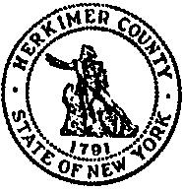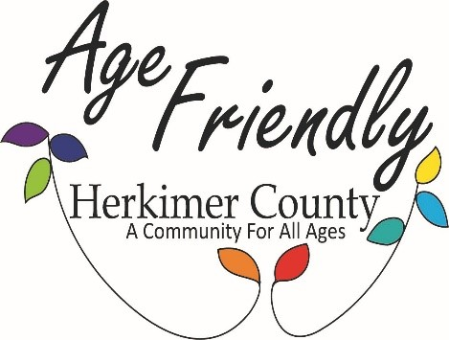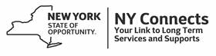

**Herkimer County Office for the Aging**

***Cost Saving Programs & Assistance for Older Adults***

* **Medicare Savings Program:** This program helps those on Medicare get the premium they pay for their Medicare Part B back in their Social Security check.
* **To qualify you must be on Medicare and be under the income levels:**

Individuals: $1,469 Couples: $1,980

* There are also two programs to assist with the cost of prescription medications- Elderly Pharmaceutical Insurance Coverage (EPIC) and the Low Income Subsidy (LIS). You can call the numbers below to see if you qualify.

**If you interested in applying call NY Connects Office for the Aging at 315-867-1121 or HIICAP at 315-894-9917**

* **The Supplemental Nutrition Assistance Program (SNAP)** is a nutrition assistance program. SNAP provides benefits to eligible low-income individuals and families via an Electronic Benefits Transfer card. This card can be used like a debit card to purchase eligible food in authorized retail food stores.
* **If you are over 60, to qualify your income must be under the income levels:**

1 person household: $2,147 2 person household: $2,903

**If you are interested in applying call Herkimer County DSS at 315-867-1291 or Catholic Charities of Herkimer County at 315-894-9917 Ext. 235 or go to** [**www.mybenefits.ny.gov**](http://www.mybenefits.ny.gov)

* **Food Pantries: Local Food Pantries can provide food items.**

To find the Food Pantry nearest you call NY Connects/OFA at 315-867-1121 or visit [www.nyconnects.ny.gov](http://www.nyconnects.ny.gov) and search Food Pantries of Herkimer County.

* **Food Sense Food Co-op Program:** Food Sense is a great way for individuals to save money and purchase quality foods for less. Each package of food or unit is filled with high quality meats, vegetables, fruits, and grocery items. **There are no restrictions-If you eat you qualify.**
* **For more information and place an order call Catholic Charities at 315-894-9917.**
* **Home Energy Assistance Program (HEAP)-** The Home Energy Assistance Program (HEAP) helps low-income people pay the cost of heating their homes.
* **Household of 1: $2,729 Household of 2: $3,569**

**To see if you qualify if you are over 60 yrs call 315-867-1195 or if under 60 yrs call 315-867-1220 or visit** [**www.mybenefits.ny.gov**](http://www.mybenefits.ny.gov)

* **Low Income Household Water Assistance Program- This programs assists with overdue water and wastewater bills. To see if you qualify visit:** [**https://otda.ny.gov/LIHWAP**](https://otda.ny.gov/LIHWAP)
* **Rental Assistance: You may qualify for funds to help pay your rent.**

Little Falls Housing: 315-823-2540 Herkimer Housing: 315-866-2252

Ilion Housing: 315-894-2159 Dolgeville Housing: 315-429-9548

**Please call the area that you reside in and for all other areas call Mohawk Valley Community Action Agency at 315-624-9930.**

* **Property Tax Relief: These programs could assist you in reducing your property taxes.**

Star Credit: To apply call 518-457-2036 or visit: www.tax.ny.gov

Senior Citizens Property Tax Exemption: Contact your assessor or visit [www.tax.ny.gov](http://www.tax.ny.gov) to locate your assessor or call 315-867-1235

Veterans Exemption: Contact you assessor to receive an application or visit [**www.tax.ny.gov**](http://www.tax.ny.gov)

* **Veterans Benefits-If you are a Veteran you may qualify for assistance.**

To see if you are eligible contact Herkimer County’s Veterans Office at 315-867-1235.

* **Adult Protective Services (APS)-** APS can assist an adult age 18 or older who may not be able to meet their own needs and have no one to assist them.

**Please contact APS at 315-867- 1231**

* **Working Solutions Career Center:** The center can assist you in finding employment or find training opportunities. **Please contact Working Solutions at 315-867-1400.**
* **NY Connects/Office for the Aging:** Our goal is to assist older adults to remain in their homes by providing services such as; transportation, meals, services to assist with personal care and housekeeping, caregiver services, legal aid, & Information & Assistance to individuals of any age. **If you need assistance call 315-867-1121.**